To the Editor

*Boundary-Layer Meteorology*

Subject: Revision of manuscript entitled “Ceilometer monitoring of boundary layer height in Seoul and its application to evaluate the dilution effect on air pollution”

Dear the editor of *Boundary-Layer Meteorology*

We appreciate the constructive comments of reviewers and editor, which helped improve our manuscript. We have revised the manuscript by incorporating all of the comments provided by the three referees and editor. Below are our responses to the reviewers.

We believe that our findings will be of interest to corresponding science communities and please do not hesitate to contact with us for your further inquiries.

Thank you very much for your support and we hope to hear from you soon.

Sincerely,

Jinkyu Hong

Department of Atmospheric Sciences, Yonsei University, Seoul, South Korea

Email: jhong@yonsei.ac.kr / hong.jinkyu@gmail.com

Fax: 82-2-2123-5693

Tel: 82-2-365-5163

**Reply to reviewers**

**Reviewer #1:**

Generally comments:

This paper reports on the determination of mixed layer height in Seoul using a ceilometer. The authors propose a modification to Emeis’ mixed layer height (MLH) determination method. They then use the results to analyse some air quality data.

Major comments:

1. Determination of the gradient from ceilometers has been done by a wide range of researchers (as noted by the authors- they give a few examples). The critical and more challenging need is to identify which of the gradients are the most appropriate for defining the MLH. There proposed modification does not improve on this or consider this. The problem their method has (e.g., nocturnal periods) is associated with this issue. I would encourage them to return to some of the more recent literature that has been associated with the extensive European Cost Action on this topic (e.g., Kotthaus and Grimmond 2018a QJRMS).

***Reply:*** Thank you for constructive comments on our manuscript. As the reviewer suggested, we carefully selected terminology for different definitions of atmospheric boundary layer depths and consistently used in our manuscript. Additionally, we emphasize our contribution to ceilometer studies in a different aspect compared to a theoretically nice work of Kotthaus and Grimmond (2018; KG18 hereafter). As KG18 clearly pointed out theoretically, it is not practically easy to deal with effects of cloud, precipitation, stable boundary layer in retrieving aerosol mixed layer from a ceilometer backscatter signal. We believe that KG18 is a good attempt to deal with these aspects and contribute to improve our understanding of the limitation of the ceilometer retrieved mixed layer depth.

Our study tries to solve these issues in the mass rather than focusing on individual issue one by one such as the study by KG18, while we were not successful to show these contributions clearly in our original manuscript. Our study started from parameter uncertainties in the retrieval procedure and in aspects of signal processing, the parameter optimization is useful in reducing a noise-driven detection of the boundary layer by designing appropriate low-pass filters in processing the data. Our study shows that our approach produces reliable information on the mixed layer depth only with a simple optimization and simple algorithm.

It is also notable that a ceilometer-retrieved boundary layer depth is adjusted to match with a temperature inversion layer. Two layers are different from each other but our parameter optimization produces the depth which is relevant to the aerosol mixed layer depth. In general, turbulent mixed layer is 10% higher than a temperature inversion but we can easily match them because the entrainment zone has some depth.

In this perspective, we believe that our approach provides useful information on a science community. We also believe that our approach is useful from an operational point of view. We revised our manuscript to incorporate the reviewer’s suggestion and to transfer better readability. Thank you for your constructive comments.

2. The definition of ZUBL needs to be more careful as there is a difference between MLH and mixing height etc. and which has been determined is strongly dependent on the method of determination (radiosonde, ALC, Doppler Lidar, etc.).

***Reply:*** We revised our manuscript based on the terminology for definitions of several kinds of boundary layer in KG18.

3. Put your adjustable parameter values for ceilometer ZUBL determination into a more general context – i.e. are we converging towards common values or not.

***Reply:*** We attempt to find out a parameter set to give the best match with a temperature inversion from radiosonde observations. As the reviewer pointed out, a ceilometer gives us the aerosol mixing depth, which is known to be larger than the temperature inversion in general (Stull, 1988, Introduction to boundary layer meteorology). Previous studies don’t provide enough information on the relationship of these two depths but we expect that this relationship depends on temperature gradient in the free atmosphere, sizes and trajectory of eddies and etc. Importantly our findings suggest that two depths are consistently varying in time. In addition, optimized parameters are physically related to low-pass filters for detectable resolutions of the mixed layer height and depth of the entrainment layer, which may vary in space and time. In reality, evaluation of our approach in different season gives the same conclusion with relatively higher errors, indicating that the parameter values depend on time and geographical location. We revised the texts to incorporate the reviewer’s suggestion with our explanations on this issue.

4. Comment on the uncertainly of heights – impact of fitting methods. I assume there is insufficient data to bootstrap an estimate of uncertainty of the coefficients.

***Reply:*** Our approach is based on the root mean square error (RMSE) against the radiosonde measurement. These RMSEs provide overall statistical uncertainties in our values and were already described in the manuscript. As the reviewer suggested, long-term application of our study will give more reliable uncertainties which is beyond our current study and can be done after an official publication of the current study in the future. We revised our manuscript to incorporate the reviewer’s suggestion. Thank you.

5. Winter fit -applied in May/ June- given the distinct changes with season (daylength etc)- is the method specified appropriately?

***Reply:*** We considered the seasonal variation of daylength based on the astronomical data. We revised the manuscript to incorporate the reviewer’s comment.

6. How is cloud dealt with? Clear from other studies that cloud is very important to determination and interpretation.

***Reply:*** We also agree that cloud is important in retrieving boundary layer depth from a ceilometer. Schween et al. (2014), Peng et al. (2017), and KG18 tried to consider cloud explicitly. We also agree that more endeavor must be done for our better retrieval of the boundary layer depth consistently. Our method is based on Emeis et al. (2007) which does not consider cloud explicitly. However, we want to say that boundary layer clouds produce atypical properties that typical boundary layer in clear days cannot describe (e.g., temperature inversion and aerosol trap in the boundary layer) (Stull, 1988, Introduction to boundary layer meteorology). That is, it is theoretically difficult to define the boundary layer top in case of cloud within it. Based on these aspects, as we pointed out above, our study deals with the cloud implicitly and in whole. In general, cloud makes more significant change in attenuated backscatter and accordingly we define the boundary layer depth if we find out such strong vertical change due to cloud. In such case, the cloud base may be the boundary layer top. In addition, cloud base is generally located above the boundary layer top in daytime convective condition and our analysis shows that the boundary layer height having cloud above it can be detected by our method reasonably. Please also consider that in this aspect, our analysis on air pollutant focuses on daytime condition. We revised the text to clarify these points for future research and limitations of current study as the reviewer suggested.

7. The air quality analysis – figure caption and text seem to suggest very different things. At the moment these sections are not clear enough to interpret.

***Reply:*** We revised the texts as the reviewer suggested.

Minor comments:

1. L108 – 111 – delete.

***Reply:*** We deleted this sentence as the reviewer suggested.

2. Section 2.1 – what firmware etc are used?

***Reply:*** We added the firmware version of the ceilometer in the revised manuscript.

3. L132 – Given the field of view of the ceilometer the SVF comment is not relevant. What angle was the sensor at?

***Reply:*** We deleted this text as the reviewer suggested.

4. L133/4 – why analysed at 1 h time scale? Block averages?

***Reply:*** Based on our analysis, 1-hour block average produces less noise because of lengthy moving window in time. In addition, air pollution data has 1-hour averaging time.

5. L136 – attenuated backscatter coefficient.

***Reply:*** We revised the text as the reviewer suggested.

6. L153 – the noise artifacts of the instrument used need to be discussed more fully. What are they? What they influencing?

***Reply:*** We revised the text as the reviewer suggested.

7. L154-159 – basis for each of the values selected. Or if directly from literature – cite.

***Reply*:** This paragraph explains the work by Emeis et al. (2007) and please consider that we already explained the work of Emeis et al. (2007) at the first part of this paragraph.

8. L170/1 – given “day” changes through the year – indicate relative to sunrise/sunset what you are trying to achieve.

***Reply:*** Based on the astronomical data, we applied different daylength in our parameter optimization with the radiosonde measurement on December and analyzing period for two months from May. We revised the text to clarify this issue.

9. L173 – from the literature – what are the range of values used in this method – e.g. how do they vary regionally/seasonally – i.e. can we start to move to some more general values?

***Reply:***As we mentioned in our introduction, these values are not documented clearly or fixed in time and geographical location in previous studies. This is our starting point. We revised Table 2 to include the relevant information for this issue. Thank you.

10. Table 1 – add a footnote to indicate that the manufacturer software can not be modified – under adjustable parameters.

***Reply:*** We added this information as the reviewer suggested.

11. Table 2 – indicate winder day and N.

***Reply:*** We revised table 2 as the reviewer suggested.

12. L255 - worrying this is just one winter day.

***Reply:*** We evaluated our method in the same period of our data analysis (May-June, 2016) with another radiosonde observation (Table R1 below). Please also consider that typical properties of the boundary layer such as clear temperature inversion and its diurnal variation were observed in one winter day. We also discussed physical interpretation of our parameter optimization in our response to the reviewer #2

Table R1. Root mean square error and mean bias error for six retrieval algorithm evaluated against four radiosonde measurements which were launched at daytime of May 2016. Top skill scores are highlighted by bold fonts.

|  |  |  |  |  |  |  |
| --- | --- | --- | --- | --- | --- | --- |
|  | **FIR** | **SEC** | **LOG** | **E07** | **VAI** | **EE07** |
|  |  |  |  |  |  |  |
| Mean bias error (m) | 1525.7 | 756.5 | 730.8 | **-66.5** | 154.4 | -264.7 |
| Root mean square error (m) | 1803.6 | 1344.5 | 1040.5 | 932.4 | 569.0 | **390.3** |

13. L262/263 – and difference of what is measured – lowest layer detectable by the radiosonde?

***Reply:*** We defined nighttime boundary layer if a layer corresponded to the lowest temperature inversion following Seidel et al. (2010). We revised the manuscript to refer this method.

14. L299-304 –given the large range of values – median and interquartile range (IQR) may be more informative than the mean and standard deviation.

***Reply:*** We revised the figures and text to incorporate the reviewer’s comment.

15. L 325-326 – this is critical.

***Reply:*** Following KG18, we discussed this issue and limitations of our study more in section 3.2 to incorporate the reviewer’s comment.

16. Section 3.2 – writing could be made more concise.

***Reply:*** We revised the text for better readability.

17. Section 3.3 is not clear.

***Reply:*** We revised the text for clear information.

18. Section 4 - much of this is not clear and the last parts depends on section 3.3.

***Reply:*** We revised the manuscript to incorporate the reviewer’s comment.

19. Figure 1.

-Which method?

-What is your confidence of ZUBL?

-(b) need more details in methods (pre-processing etc) for that lower choice

***Reply:*** We added relevant information on these comments in the revised manuscript.

20. Figure 2.

-Need to indicate to see Table 1 for definitions

-How were the radiosonde data interpreted?

***Reply:*** Please consider that Section 2 discussed several properties of the radiosonde observation. For better readability, we revised the manuscript to incorporate the reviewer’s comment.

21. Figure 3 -Why are May and June studied if the assessment of the ceilometer is against December radiosonde data? Or why were spring radiosondes not also used?

***Reply:*** There was the extensive field air quality campaign, KORUS-AQ during the study period in spring and high resolution air pollution data were available in this period. We tested the few radiosonde data in Spring (Table R1). It shows that our method is reliable even in other season.

22. Figure 5.

-Remarkable lack of variability in standard errors – if this is all regional transport – is this a good period to analyse with ZUBL? Would median and IQR be more informative?

***Reply:*** We added IQR into Figure 5 as the reviewer suggested.

23. Figure 6.

Daytime – define

Be much clearer what this data are (hourly values, when etc) ?

Explain how SE determined

What about the errors in ZUBL?

***Reply:*** We revised the manuscript and figure 6 as the reviewer suggested. Thank you very much.

**Reviewer #2:**

General comments:

The manuscript deals with the estimation of the daytime and nocturnal height of the boundary layer from ceilometer measurements. A novel method for the estimation of the boundary-layer height is proposed. It can be looked upon as an extension of a method proposed by Emeis et al. (2007). The new method contains 3 parameters that are determined by fitting the new method to estimates of the boundary-layer height derived from an intense radiosonde campaign in central Seoul, Korea. In consequence the method and its parameters are site specific.

Major comments:

1. Results from 6 methods for estimation the boundary-layer height from ceilometer measurements are presented and compared to the estimation of the boundary-layer from the radiosonde campaign. A new method for the estimation of the boundary-layer height from ceilometer measurements is proposed - based on ideas presented in Emeis et al. (2007).The parameters in the new method are derived by fitting to radiosonde measurements. It is concluded that the method proposed by Emeis et al. (2007) showed worst performance of all the methods during both day-time and night-time (lines 243-244), while the new method shows the best statistical scores. It would be very interesting to see how Emeis et al. (2007) performs when the parameters are fitted to the measurements from Seoul and also just to see the parameter values and how they compare with the parameters in the new method.

***Reply:*** As the reviewer suggested, we applied the parameter fitting for Emeis et al. (2007) (E07 hereafter). E07 also produces better performance if the parameter optimization is applied (Table R2 and Figure R1-R2). We revised the manuscript to include this result. Thank you.

Table R2. Optimized parameters and skill scores obtained for each retrieval algorithm evaluated against radiosonde observations launched on 29 December 2016. Due to evaluation purposes, both of optimized and not optimized parameter of E07 were discussed, while parameters in the algorithm provided by the ceilometer manufacturer, VAI, could not be modified. Instead, the original parameters proposed by Emeis et al. (2007) and Münkel et al. (2007) were applied, respectively. Top skill scores are highlighted by bold fonts.

|  |  |  |  |  |  |  |  |
| --- | --- | --- | --- | --- | --- | --- | --- |
|  | **FIR** | **SEC** | **LOG** | **E07** | **E07_new** | **VAI** | **EE07** |
| **Optimized parameter values** |  |  |  |  |  |  |  |
| **Daytime (9:00-18:00 h)** |  |  |  |  |  |  |  |
| $w_{v}$ (m) | 480 | 480 | 40 | 80-160 | 60 | 80–360 | 140 |
| $w_{t}$ (s) | 1440 | 2080 | 640 | 900 | 2080 | 3120 | 160 |
| $∆z$ (m) | 40 | 420 | 460 | 80-160 | 60 | 80–360 | 300 |
| **Nighttime (18:00-9:00 h)** |  |  |  |  |  |  |  |
| $w_{v}$ (m) | 100 | 480 | 80 | 80-160 | 40 | 80–360 | 80 |
| $w_{t}$ (s) | 2080 | 1920 | 2240 | 900 | 2400 | 840 | 2400 |
| $∆z$ (m) | 180 | 480 | 480 | 80-160 | 40 | 80–360 | 40 |
| (10-9 m-1 sr-1) | - | - | - | 200-250 | 250 | dependent on | - |
| (10-9 m-2 sr-1) | - | - | - | -0.6 | - | - |  |
|  |  |  |  |  |  |  |  |
| **Skill score** |  |  |  |  |  |  |  |
| **Daytime (9:00-18:00 h) (N=9)** |  |  |  |  |  |  |  |
| Mean bias error (m) | **-5.7** | -295.2 | 14.3 | 421.8 | 317.5 | -65.8 | -15.1 |
| Root mean square error (m) | 108.7 | 321.5 | 140.0 | 467.1 | 360.5 | 143.2 | **68.2** |
| Correlation coefficient (r2) | 0.77 | 0.75 | 0.53 | 0.10 | 0.26 | 0.61 | **0.91** |
| **Nighttime (18:00-9:00 h) (N=9)** |  |  |  |  |  |  |  |
| Mean bias error (m) | 557.5 | 279.9 | 688.0 | 1196.6 | 1136.6 | 370.2 | **-60.0** |
| Root mean square error (m) | 595.6 | 357.5 | 704.9 | 1206.6 | 1141.5 | 449.7 | **132.2** |
| Correlation coefficient (r2) | 0.02 | 0.05 | 0.00 | 0.00 | 0.12 | 0.04 | **0.50** |
| **Complete diurnal course (N=18)** |  |  |  |  |  |  |  |
| Mean bias error (m) | 275.9 | **−7.6** | 362.5 | 809.2 | 727.0 | 152.2 | −37.5 |
| Root mean square error (m) | 428.1 | 340.0 | 519.9 | 914.9 | 846.5 | 333.7 | **105.2** |
| Correlation coefficient (r2) | 0.51 | 0.46 | 0.48 | 0.14 | 0.13 | 0.59 | **0.96** |

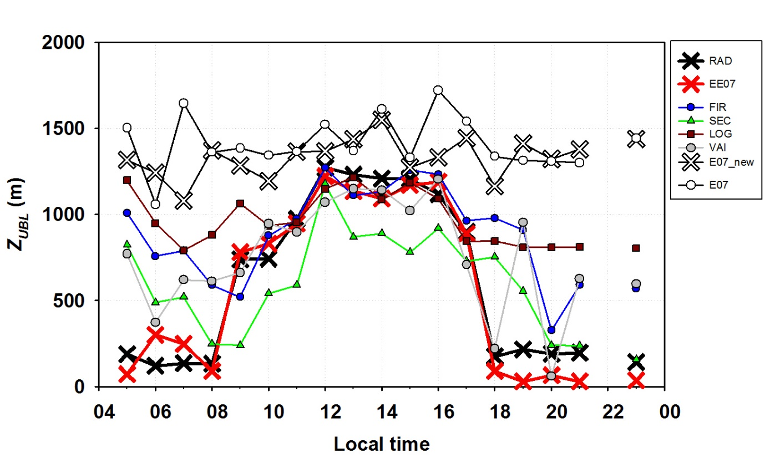

Figure R1. Retrieved *Z*△T and *Z*ML on 29 December 2016 from thermodynamic radiosonde profiles (RAD) and EE07, FIR, SEC, LOG, VAI, E07 (without parameter optimization) and E07_new (with parameter optimization) evaluated in this study based on the gradient method using attenuated aerosol backscatter profiles measured by a commercial ceilometer.

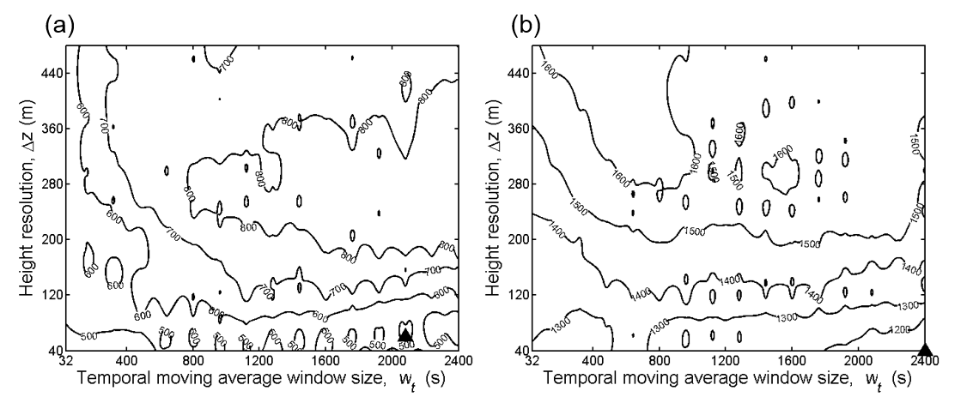

Figure R2. Root mean square error (RMSE) distributions of the *Z*ML comparing with *Z*△T from radiosonde. Emeis et al. (2007) (E07) algorithms for (a) daytime and (b) nighttime, respectively. The optimized parameter values are indicated by triangles. Each RMSE distribution is given at $B_{min}$ is 250•10-9 m-1 sr-1 and is -0.60•10-9 m-2 sr-1.

2. The parameters relates to the physical properties of the boundary-layer, especially because of the large difference between the parameter values between day and night fitting parameters in the new method have units of m and sec; I suggest adding a discussion on how these

***Reply:*** As the reviewer suggested, we added more discussion on the relationship of the parameters with the physical properties into the manuscript. The moving average window sizes ( $w_{v}$ and $w_{t}$) are working as a low pass filter and our results show that we should use different levels of signal in a diurnal course: $w_{v}$ and ∆*z* are related to the PBL vertical scales of eddy and noise, and depth of the entrainment zone, respectively. $w_{v}$ and ∆*z* at nighttime show smaller value than at daytime, indicating that nighttime eddy size is relatively smaller. $w_{t}$ can be interpreted as two point of view; noise and PBL temporal scale. Since PBL vertical scale is smaller at nighttime, noise level is relatively larger. In terms of PBL temporal scale, height of PBL does not frequently change at nighttime as daytime height of PBL does. Thus, larger $w_{t}$ should be applied to obtain a meaningful signal. Indeed, $w_{t}$ at nighttime has a larger value than at daytime.

3. The new method "d**2 B/d (z-1)**2 less than or equal to zero", thus it contains a number "1" with units. The units should be clarified, or even better the formulation made dimensionless on line with Emeis et al. (2007). And undoubtedly the estimation of the boundary-layer height will be sensitive to the units that are assigned to this number. Please clarify and discuss the sensitivity.

***Reply:*** We are sorry that our index convention is not clear. In our manuscript, variable “z” refers to the zth vertical level of ceilometer outputs. Accordingly, a number “1” indicates 10 m. We revised the manuscript for clear information.

4. From table 2 and figure 2 it can be seen that that the simple methods based on the first derivative (dB/dz) works very well during daytime both with respect to mean bias and RMSE, considering that these methods are completely independent and never was fitted to the measurements from Seoul. This is especially so for the simple method proposed by Vaislala. I suggest adding a discussion on the excellent performance of these independent and simple methods.

***Reply:*** Our main focus is that the parameter optimization to a simple algorithm produces better performance. But we simply mentioned that a few methods including the Vaisala method reproduced relatively better results without the parameter optimization.

5. I am in doubt how the authors handle the effect of the residual layer when determining the height of the night-time boundary-layer from ceilometer measurements. During night-time the methods based on the dB/dz as well as Emeis et al. (2017) obviously detects the top of the residual layer (the height change little from daytime to nighttime), while the new method by the parameter fitting is able to estimate the much lower boundary-layer from the ceilometer measurements. Please provide an exhaustive discussion on the way that the boundary-layer height is distinguished from the residual layer. Please explain the physics and how this is reflected in the new model.

***Reply:*** Our method totally depends on vertical gradients of ceilometer backscatter (*B* hereafter). This may not represent the residual layer (RL hereafter) properly as the reviewer suggested. We also had the similar opinion on this issue at first and we mechanically allocated the lowest minimum of *B* in nighttime. However, one of our interesting findings is that we could find an inflection point of *B* which matched with the temperature inversion even in nighttime. This proposes the possibility to detect nighttime temperature inversion layer (we called this layer as the stable boundary layer) in general only with appropriate simple filtering. But we also admit that this method makes larger uncertainties in nighttime values from a ceilometer. We revised the text to incorporate this issue. Thank you.

6. Figure 5. There is no common behavior between the diurnal variation of the air pollutants measured at the rural (coastal) island of Bengnyeong more than 200 km from the heavily urbanized city of Seoul. The behavior of the boundary-layer height at the two sites will therefore not be similar. I therefore suggest that the authors remove the part of the analysis that is based on the measurements from the Bengnyeong island from the manuscript.

***Reply:*** The background air pollution measured in the Baengnyeong station is necessary since 1) the concentration of Baengnyeong station gives us the background information, 2) based on this background information, we found out that local emission is important for primary pollutants and advection (long distance transport from the west) is important for PM, and 3) accordingly, air pollutants concentration in Seoul is suitable for applying for the PBL dilution effect. In these perspectives, we revised the manuscript in section 2.4 and 3.3 to emphasize why we need and use Baengnyeong data in our manuscript rather than removing this paragraph.

Minor comments:

1. Line 136: is it "attenuated backscatter" or backscatter", please clarify.

***Reply:*** As the reviewer suggested, we used “attenuated backscatter” consistently throughout the manuscript.

2. Line 269 - this is a good place to explain in detail what is meant by "filter threshold". This term needs clarification.

***Reply:*** The filter threshold referred to *B*min in EE07 and we revised the text to use *B*min in the manuscript to incorporate the reviewer’s suggestion.

3. Line 392: should be summer - not spring.

***Reply:*** We revised the text as the reviewer suggested.

4. The formulation of the method of Emeis et al. (2007) on lines 163-165 is different from the formulation presented in table 1 ((z+ delta-z/z) in lines 163-165 and (z-1) in table 1.

***Reply:*** We revised the text to incorporate the reviewer’s suggestion.

5. Add the correlation coefficient to the skill score for daytime and nighttime in table 2. Presently it is given for the complete diurnal course only.

***Reply****:* We revised the manuscript as the reviewer suggested. Thank you very much.

**Reviewer #3**

General comments:

Based on radiosonde observations, the author proposed a modified algorithm to calculate the urban boundary layer height (ZUBL) with ceilometer data. Then, two-month ZUBLs in 2016 were calculated and compared with 5 pollutants (PM10, CO, SO2, NO2 and O3). It is found that ZUBL shows strong negative correlations with primary emitted pollutants such as PM10, CO, SO2, and NO2, and a less strong positive correlation with O3. The paper is well-written and worth publication.

One concern is about the UBLH calculation. The parameters of EE07 are optimized with only 18 radiosonde profiles in one day, which may be somewhat limited. Further, the 18 radiosonde profiles are firstly used to retrieve the algorithms' parameters, and then used again to justify the EE07 parameters, which is merely self-justification, so that its reliability is questionable. I encourage the authors to find more profile data (such as the data from meteorological services), and use these extra data as a verification.

***Reply:*** As the reviewer suggested, we applied for another profile data during the study period (See Table R3 below). This test gives us the similar results with our manuscript. Thank you.

Table R3. Root mean square error and mean bias error for six retrieval algorithm evaluated against four radiosonde measurements which were launched at daytime of May 2016. Top skill scores are highlighted by bold fonts.

|  |  |  |  |  |  |  |
| --- | --- | --- | --- | --- | --- | --- |
|  | **FIR** | **SEC** | **LOG** | **E07** | **VAI** | **EE07** |
|  |  |  |  |  |  |  |
| Mean bias error (m) | 1525.7 | 756.5 | 730.8 | **-66.5** | 154.4 | -264.7 |
| Root mean square error (m) | 1803.6 | 1344.5 | 1040.5 | 932.4 | 569.0 | **390.3** |

Minor comments:

1. Line 24: 'dilution' may be changed to 'dilution/accumulation' to include the accumulation effect after sunset.

***Reply:*** Please consider that we analyzed the daytime data only and so we want to use dilution instead of accumulation.

2. Line 68: 'dilute' changed to 'are diluted'.

***Reply:*** We revised the text to incorporate the reviewer’s comment.

3. Line 99: 'levels' changed to ' levels,', i.e., add a comma.

***Reply:*** We revised the text to incorporate the reviewer’s comment.

4. Line 197: The abbreviation 'E07' should be given here.

***Reply:*** We revised the text to incorporate the reviewer’s comment.

5. Line 357: the conclusion of 'The entrainment process with the overlaying FA …' is lack of evidence.

***Reply:*** There are previous studies to support this conclusion and please consider that this statement explains several hypotheses for our findings. We added the references and revised the text for better readability. Thank you.

6. Line 567: The precipitation bars should not reach the maximum of y-axis.

**Reply:** We revised Figure 3 to incorporate the reviewer’s comment. Thank you very much.